**Register and Configure an App in Facebook:**

**1. Login to Facebook**

**2. Create a Developer Account**

**3. Create a New Facebook App**

**4. Set Your App Details**

**5. Choose a Platform for Your App**

**6. Set Advanced Settings**

**7. Assign Developer Roles**

**8. Create Test Users**

**9. Update Development Mode Status**

**10. Submit Your App for Review**

**Detailed Steps** :

Before creating a developer account, login in to your Facebook account.

1. [Login to Facebook](https://developers.facebook.com/docs/apps/register/#login) : Log into Facebook using your credentials

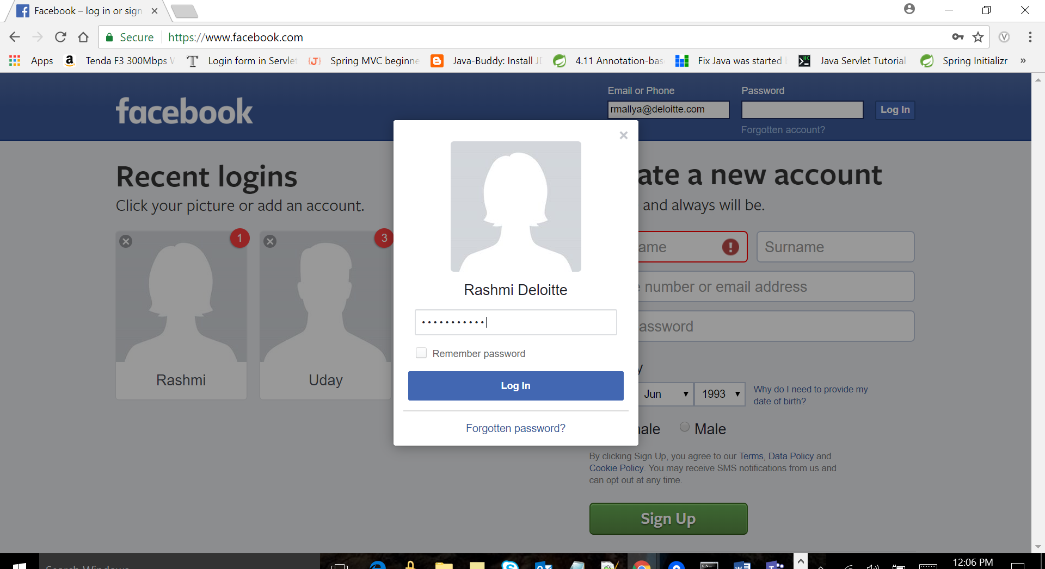

1. Create a Developer Account: If you don't have a Facebook Developer Account, create a one. Go to <https://developers.facebook.com/>

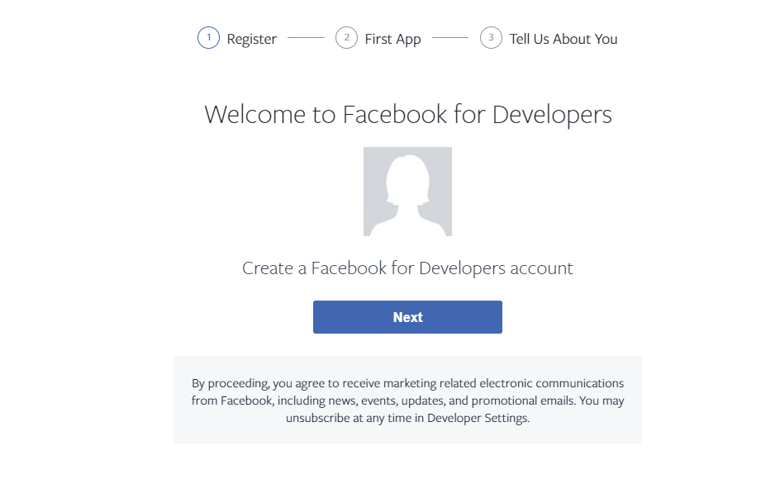

1. [Create a New Facebook App](https://developers.facebook.com/docs/apps/register/#create-app) : By creating a **Facebook App**, Facebook creates an **App ID** which is an object that represents your actual application and which stores settings and information for it. A Facebook App ID is created that represents your app.In the top navigation bar of [Facebook for Developers site](https://developers.facebook.com/) select **Add a New App** or use the button below.

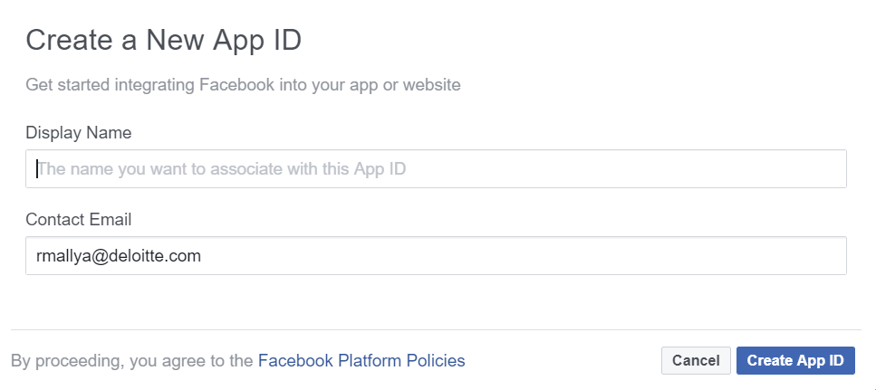

1. Set your App Details :

After you create an app, you will be taken to your [App Dashboard](https://developers.facebook.com/apps/). Select the app you wish to view. In the left side navigation panel of the App Dashboard, click **Settings > Basic** to view the **App Details**Panel with your **App ID**, your **App Secret**, and other details about your app. Update or change the name, email, and other details of your app.

* **Your App ID** - A unique ID given to your app to use whenever you use one of our [APIs or SDKs](https://developers.facebook.com/docs/apis-and-sdks).
* **Your App Secret** - A unique secret associated with your application that authenticates requests made by your application to Facebook servers. Your App Secret should be treated like a password.
* **App Name** - A name has been supplied but change this to the name you prefer.
* **Contact Email** - A contact email for this app.
* **App Domains** - Provide Google Play and/or Apple App Store URL of your app.
* **Privacy Policy URL** - You must provide a [Privacy Policy](https://en.wikipedia.org/wiki/Privacy_policy) URL. *Must be provided to take your app public.*
* **Terms of Service URL** - You must provide a [Terms of Service](https://en.wikipedia.org/wiki/Terms_of_service) URL.
* **App Icon** - Artwork or image used to identify your app.
* **Category** - Choose the category type of your app.

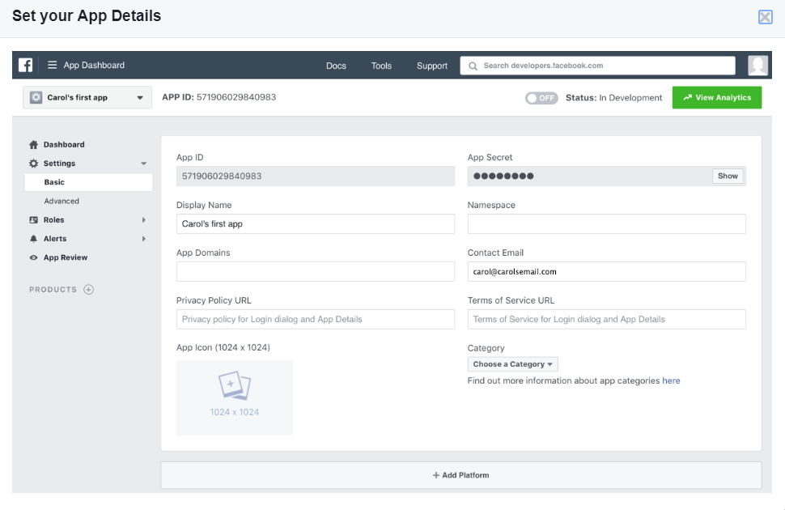

1. Choose a platform : Below the App Details Panel is an **Add Platform** button. Click this to choose the platform you want to add. If your app is on multiple platforms, you will be able to add each to your Facebook app. Fill out information for each platform type.

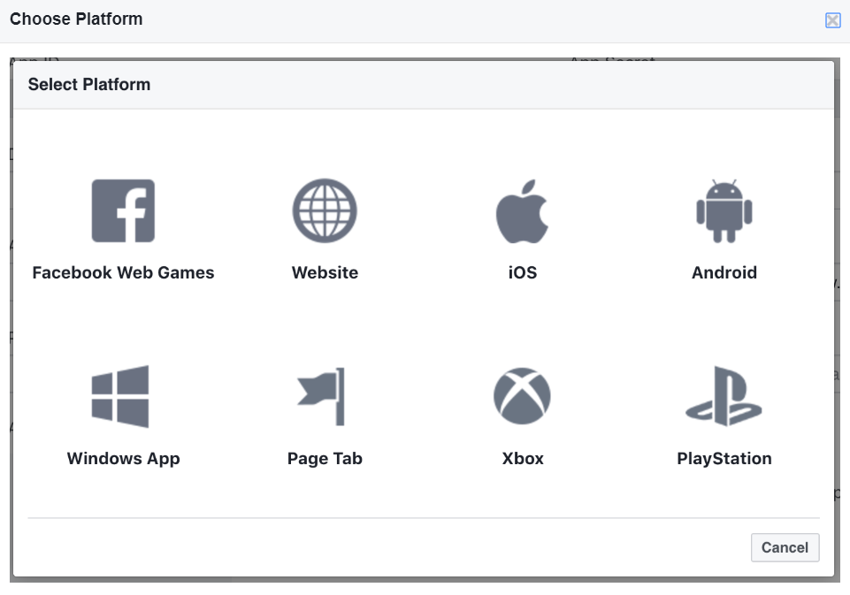

1. Set Advanced Settings :

Under **Settings > Advanced**, you can:

* **Upgrade the API Version** - Change the [API version](https://developers.facebook.com/docs/apps/versions) your app uses to call the Facebook Social Graph.
* **App Restrictions** - Set Age, Country, Alcohol restrictions and Social Discovery on your app.
* **Security** - View and reset your Client Token, set your Server IP Whitelist and other security requirements.
* **Domain Manager** - Add domains or domain prefixes to be [prefetched by Facebook](https://www.facebook.com/business/help/1514372351922333/).
* **App Page** - Create a Facebook Page for you App.
* **Business Manager** Associate your app with a business to [manage your apps](https://developers.facebook.com/docs/apps/business-manager).This represents the company which owns the application to advertise.
* **Advertising Accounts** - Provide one or more IDs for authorized [Ad Accounts](https://www.facebook.com/ads/manager/accounts/) to be used to run and pay for app ads. If more than one business plans to run app ads for the app, also provide the Business Manager IDs for those businesses. For example if a business runs ads for a subsidiary or if an agency runs ads for a client, provide the business manager IDs in Authorized Businesses.
* **Migrations** - Turn on [migrations](https://developers.facebook.com/docs/apps/versions) to roll out API changes.
* **Share Redirect Whitelist** - Allow cross domain [share redirects](https://developers.facebook.com/docs/sharing/) to your urls.
* **Delete App** - Permanently delete an app and all its data.

1. Assign Developer Roles :

Developer Roles allow you to control who has permission to view app details and analytics, edit app details, and test your app.

* **Administrators** - Administrators have complete access to your app.
* **Developers** - Developers can test your app, view insights, and change most app settings. They cannot add or remove roles, reset the app secret, or delete the app.
* **Testers** - Testers can only test the app in Development Mode, i.e. not public.
* **Analytic Users** - Analytic users can only access app analytics. They cannot access app settings or test your app while it is in Development Mode.

1. Create Test Users :

Create [test users](https://developers.facebook.com/docs/apps/test-users/) to test your app's Facebook integration. You can create four test users at one time, set the test user's age, and set the test user's language.

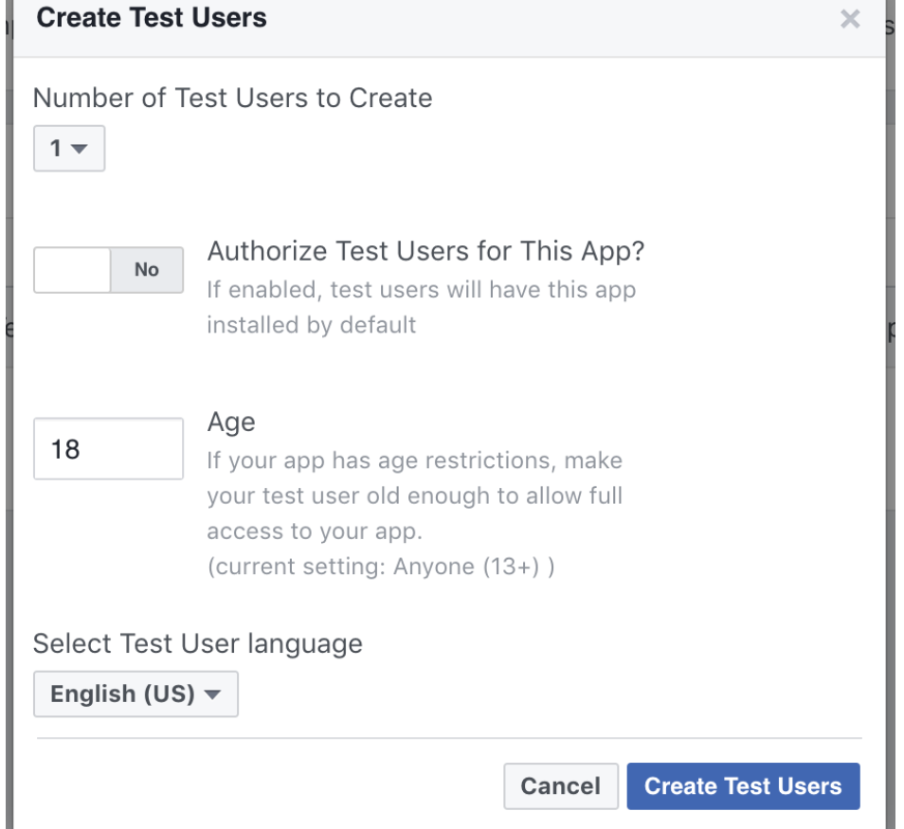

1. Update Development Mode Status: New Facebook apps exist in development mode by default. This limits actions and objects to Facebook Timelines owned by a developer of the application. Once your application is ready for public use you can switch from development mode to public mode to allow your app to interact with Facebook accounts not associated with your app.In your App Dashboard's upper right corner next to the **View Analytics** button, click the **Status** toggle switch from **OFF.**

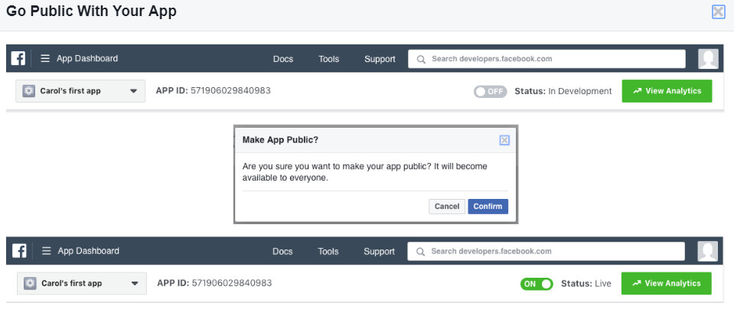

1. Submit your app for review: If your app uses advanced FB Login or Messenger permissions, or if you want your app to be listed in App Center, you need to submit the app for review. Learn more about the review process and what's required to pass review in the [Login Review Guide](https://developers.facebook.com/docs/facebook-login/review).

